The Immune System and Immune Mediated Diseases
Dan Lodge-Rigal, M.D.

Outline:

1. Review of Hypersensitivity Reactions
2. Systemic Autoimmune Diseases
a. Tolerance and mechanisms of autoimmunity
b. Autoantibodies
c. Systemic Lupus Erythematosus
d. Sjogren Syndrome
e. Systemic Sclerosis
f. Inflammatory myopathies
g. Mixed connective tissue disease

3. Pathology of Transplantation
a. Mechanisms of rejection
b. Morphologic features of rejection
c. Increasing graft survival
d. Graft versus host disease
e. Other complications.

4. Laboratory Assessment of Immune Status

5. Immunodeficiency: Congenital and Acquired
a. Acquired versus congenital immunodeficiencies
b. Clinical manifestations of congenital immunodeficiencies
c. Selected Congenital Immunodeficiencies
X-linked agammaglobulinemia (Bruton's)
Common Variable Immunodeficiency
IgA Deficiency
Hyper IgM Syndrome
Thymic hypoplasia (DiGeorge Syndrome)
Severe Combined Immunodeficiency (SCID)
Wiskott-Aldrich Syndrome

d. Acquired Immunodeficiency
Pathology and Pathogenesis of HIV Infection

6. Amyloidosis

Reading: Robbins Basic Pathology pp 110-120 (review-hypersensitivity), 120-159 (new)
Autoimmunity and Autoimmune Disease

Tolerance and Mechanisms of Autoimmunity

Mechanisms of Immunologic Tolerance

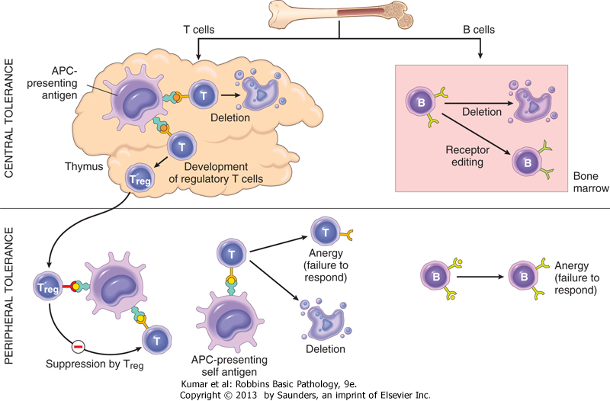
Central:

Peripheral:

Mechanisms of Autoimmunity

Barriers to intrathymic deletion

PROTECTED SITES
AUTOIMMUE REGULATOR (AIRE): stimulates expression of self Ag
SEQUESTERED: lens, testis

Genetic factors and "suseceptibility genes"

HLA ASSOCIATIONS: “predisposition”
Mutations: FAS-FAS ligand, AIRE (not single gene)

Infections and Autoimmunity

TISSUE DAMAGE: altered Ag structure (epitope spreading)
INDUCTION OF INFLAMMATORY CYTOKINES, HLA expression
COSTIMULATORY MOLECULE EXPRESSION
MOLECULAR MIMICRY

Tissue injury (UV light)

Other factors

DRUGS (procainamide), COMPLEMENT DEFICIENCY, EXTRINSIC ANTIGEN
Autoantibodies

Role in autoimmune disease:

1) DIRECT CELLULAR DAMAGE

2) RECEPTOR STIMULATION

3) IMMUNE COMPLEX DISEASE

4) UNCERTAIN SIGNIFICANCE

Antinuclear Antibodies

Definition:

Detection of ANA: Immunoassay (automated) versus indirect immunofluorescence.

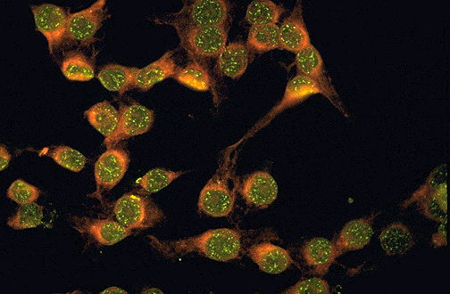ANA: patterns of immunofluorescence:

1) HOMOGENEOUS/DIFFUSE
anti-chromatin, histone, dsDNA

2) RIM/PERIPHERAL
anti- dsDNA

3) SPECKLED
non-DNA nuclear antigens (ENA’s)

4) NUCLEOLAR
assoc with PSS

Systemic Autoimmune Diseases

Tests for systemic inflammation:

C-reactive protein
FROM LIVER, ACUTE PHASE REACTANT, SHORT T1/2, EARLY MARKER

Erythrocyte sedimentation rate (ESR or Sed rate)
INCREASED PROTEIN (globulin, fibrinogen)
NORMAL 1-20 mm/hr
INCREASED: pregnancy, anemia, macrocytosis
DECREASED: polycythemia, abnormal RBCs, technical factors, abnormal proteins

Other: HYPERGAMMAGLOBULINEMIA, HYPOCOMPLEMENTEMIA

Systemic Lupus Erythematosus

Defining: multisystem, variable signs/symptoms and clinical course

Diagnostic criteria (Revised Criteria)

Demographics

Prevalence: 40/100,000 (Northern European) 200/100,000 (blacks)

Sex: 90% are FEMALE, 9:1 female: male
Age: young-middle age (females 15-50 years of age)
Race: 1/245 prevalence in black women, more severe disease

Pathogenesis
Genetic factors

1) TWINS: 25% CONCORDANCE IN MZ TWINS vs 2% DZ

2) WHOLE GENOME SCANNING: MULTIPLE SUSCEPTIBILITY
GENES, INCL HLA IDENTIFIED

3) NULL ALLELES IN COMPLEMENT GENES AND EARLY COMPLEMENT
COMPONENT DEFICIENCIES

Environmental factors
1) HORMONES: SEX HORMONES

2) DRUGS: PROCAINAMIDE, HYDRALAZINE, QUINIDINE

3) INFECTIONS: EVB

4) UV LIGHT

5) CIGARETTE SMOKING ? mechanism

Immune system abnormalities
1) IFN alpha STIMULATION

2) TOLL-LIKE RECEPTOR MEDIATED SIGNALING ACTIVATES
SELF-REACTIVE B CELLS

3) FAILURE OF B CELL TOLERANCE (CENTRAL AND PERIPHERAL TOLERANCE BREAKDOW

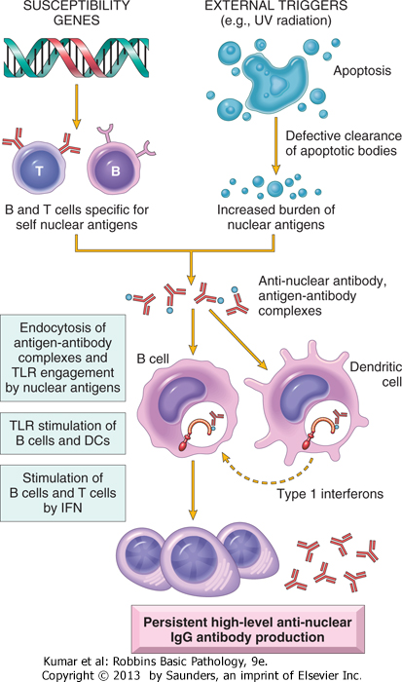

Autoantibodies

Antinuclear antibodies:

anti-dsDNA (peripheral/rim distrib)
anti-Sm
- ANA R/O SLE

Antiphospholipid antibodies:
Assoc w/thrombosis (arterial)
Present in 40-50% of pts w/SLE
Also PRIMARY APS occurs
Interacts with plasma proteins/phospholipid in
PTT assay “lupus anticoagulant”
Related: Anti-cardiolipin antibody
False + RPR

Other autoantibodies:

Mechanism of tissue injury:
1) DNA/ANTI DNA complexes in vessel walls (Type III)

2) Anti-RBC/Anti-WBC antibodies + complement (Type II)

3) LE cell (obsolete

Pathology of Systemic Lupus Erythematosus

Blood vessels:
NECROTIZING VASCULITIS

Kidneys:

SPECTRUM: mild renal insuff – acute nephritis – rapid progression/nephrotic synd.
Glomerulonephritis: (Class I-VI)
“Normal” – may still have deposits by EM/IF
Diffuse Proliferative: most serious, crescents, necrotizing lesions
Deposits: mesangial, subepi, subendothelial
Wire Loop lesions: worse prognosis
TITER of anti-dsDNA correlates with renal disease activity

May also see tubule-interstitial inflammation/damage

Skin:
MALAR RASH 50%
typical HISTOLOGY: basal layer liquifactive change, deposits of Ig/Comp at D-E jct
PHOTOSENSITIVITY

Joints:
SYNOVITIS- non-EROSIVE, ARTHRALGIAS, MYALGIAS
Fusiform swelling of fingers, wrists, knees

Central nervous system:
NON-VASCULITIC OCCLUSION (APA), PSYCHOSIS, SEIZURES, OTHER-FATIGUE, DEPRESSION

Cardiovascular:
ACCELERATED CAD
LIBMAN SACKS ENDOCARDITIS

Other:
Lungs ALVEOLAR INJURY, FIBROSIS

Liver AUTOIMMUNE HEPATITIS

Spleen ONIONSKIN LESIONS

Serosal Surfaces: PLEURITIS, PERICARDITIS

Presentation and clinical course

VARIABLE PRESENTATION AND CLINICAL COURSE

3 “GROUPS”
1) Anti RNP, Anti-Sm
2) Anti Ro, LA, anti ds-DNA
3) Anti cardiolipin, LA, (APS) anti ds-DNA

Treatment

Mild- Moderate disease: HYDROXYCHLOROQUINE-mainstay of therapy

Severe disease: STEROIDS, CYTOTOXIC AGENTS: azathioprine, anti-TNF
B-cell targeted therapy: anti BLyS, anti CD20 (rituximab)

Survival

80% 5 year survival (compared with 50% in 1950’s)
Death from infection, accelerated atherosclerosis
Other: severe CNS disease, thromboembolism

Variants of Lupus:

Discoid lupus
SKIN INVOLVEMENT WITH ONLY RARE SYSTEMIC DISEASE (5%)
DIFFERENT SKIN LESIONS

Drug Induced
HYDRALAZINE, ISONIAZID, PENICILLAMINE
DISEASE USUALLY REMITS AFTER WITHDRAWAL OF DRUG
ASSOC W/ +ANA - dsDNA

SUBACUTE CUTANEOUS LUPUS: WIDESPREAD NON-SCARRING SKIN LESIONS, MILD SYSTEMIC DISEASE.

Sjogren Syndrome

Definition:
AUTOIMMUNE DISEASE CHARACTERIZED BY--

1) DRY EYES : XEROPHTHALMIA

2) DRY MOUTH: XEROSTOMIA

3) LYMPHOCYTIC INFILTRATION OF SALIVARY GLANDS

PRIMARY : SICCA SYNDROME

SECONDARY “ associated with another autoimmune disorder –RA”

Clinical presentation
90% are female 40-60 years old
Bilateral salivary gland (parotid) enlargement
SICCA syndrome as above
Other manifestations similar to other systemic CTD: arthralgia/arthritis, Raynaud, lymphadenopathy, repiratory symptoms, myositis

Pathogenesis:

Cellular and Humoral mechanisms
CD4 mediated inflammation directed at exocrine duct cell antigens
B cell activation—ANA, RF
? mech of tissue injury
? viral etiol- EBV, HIV HCV

Laboratory findings:

ANA: positive in 50-80%
90% are anti-RNP: SS-A (Ro) , SS-B (La)

Rheumatoid factor (RF) : 75%

Pathologic features:

1)lymphocytic infiltrate in salivary/lacrimal glands, atrophy

2) non Hodgkin lymphoma (40X increase)

3) renal involvement (

Multisystem disease

Extraglandular involvement occurs in 25-30 %
Associated with HIGH TITER OF Anti-SSA

Examples:

1) peripheral neuropathy

2) lung- fibrosis

3) kidney- T-I disease

4) myositis, arthritis

Diagnosis:

ANA testing
minor salivary gland biopsy
tear/salivary studies

Treatment:

Symptomatic, anti-inflammatory
Tear/Salivary replacement
Steroids- for severe extra glandular involvement
Systemic Sclerosis (Scleroderma)

Definition:
AUTOIMMUNE DISEASE CHARACTERIZED BY EXCESSIVE FIBROSIS THROUGHOUT THE BODY: SKIN, GI TRACT, LUNGS, KIDNEYS, HEART

Prevalence:
3X MORE COMMON IN WOMEN
INCIDENCE: 2/100,000/YR
PREVALENCE: 25-75 /100,000

Diffuse scleroderma:
RAPID COURSE
SYMMETRIC SKIN THICKENING
HIGH RISK OF VISCERAL INVOLVEMENT

Localized scleroderma:
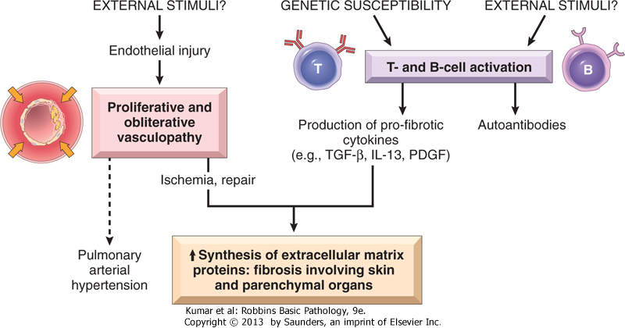
SKIN CHANGES LIMITED TO FACE
AND EXTREMITIES

CALCINOSIS
RAYNAUDS
ESOPHAGEAL DYSMOT
SCLERODACTYLY
TELANGIECTASIAS

Etiology/Pathogenesis:

Endothelial cell injury
? MECHANISM
Immune activation
T CELLS AND SELF ANTIGEN

Fibrogenic cytokines
TGF-BETA
PDGF

B-CELL ACTIVATION AND
Autoantibodies:

1) ANTI DNA TOPOISOMERASE 1(SCL-70)
70% W/DIFFUSE DISEASE
2) ANTI-CENTROMERE
90% W/LOCALIZED-CREST

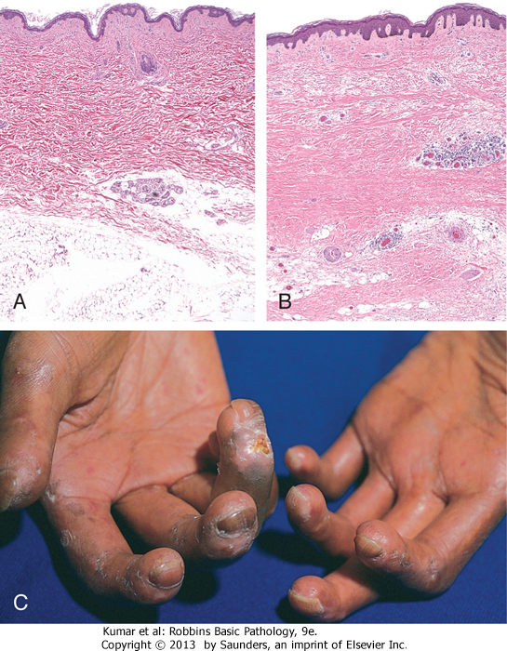
Pathologic features:

Skin
DIFFUSE SCLEROTIC ATROPHY
FINGERS FIRST, THEN MORE PROXIMAL
VASCULAR THICKENING
CALCINOSIS
LOSS OF NAIL FOLD CAPILLARIES

GI tract 90% OF PATIENTES
FIBROSIS OF MUSCULARIS
ESOPHAGEAL DYSMOTILITY
PEPTIC/REFLUX DISEASE
MALABSORPTION

Kidney
ARTERIAL CHANGES-ONIONSKIN
30% DEVELOP HYPERTENSION, HIGHER INCIDENCE OF MALIGNANT HYPERTENSION

Lungs
FIBROTIC LUNG DISEASE
Heart
MYOCARDIAL FIBROSIS

OTHER…

Presentation and Clinical Course

Raynaud phenomenon PRECEDING SYMPTOM IN 70%

Skin changes

Visceral involvement and associated symptoms

JOINT PAIN STIFFNESS
RESPIRATORY SX/SX
RENAL INSUFF, MALIGNANT HTN

Treatment:
ASA/NSAID
STEROIDS
STRONGER IMMUNOSUPPRESSIVES FOR SEVERE DISEASE
D-PENICILLAMIINE: DECREASES SKIN CHANGES

Prognosis/Survival:
10 YEAR SURVIVAL 35-70% OVERALL. BETTER WITH LOCALIZED SS

Other Autoimmune Disorders:

Inflammatory Myopathies DISCUSSED ELSEWHERE

Dermatomyositis
ADULTS AND CHILDREN
HELIOTROPE SKIN RASH
MYOPATHY: MUSCLE WEAKNESS
PROXIMAL THEN DISTAL
MAY HAVE EXTRAMUSCULAR DZ: LUNG
CAPILLARIES ARE MAJOR TARGET OF INFLAMM

Polymyositis
ADULTS
DIRECT IMMUNE ATTACK OF MUSCLE
ASSOC W/ NEOPLASMS, OTHER CTD
6-45% HAVE UNDERLYING CANCER (LUNG, STOMACH, OVARY)

Associated autoantibody:
ANTI T-RNA SYNTHETASE (ANTI JO-1)

OTHER FDGS: ELEVATED CPK
DX: EMG, MUSCLE BIOPSY

Mixed Connective Tissue Disease

Definition
OVERLAP SYNDROME (? SPECIFIC ENTITY)
MIXED FEATURES OF LUPUS, PSS, POLYMYOSITIS

Associated autoantibody:
ANTI –U1-RNP
EVENTUALLY MAJORITY DEVELOP DIAGNOSTIC CLINICAL CRITERIA FOR ONE OF CTDZ WITHIN 5 YEARS

Pathology of Transplantation

1ST KIDNEY TXP DEC 2 1954
IDENTICAL TWINS AT PETER BENT BRIGHAM HOSPITAL BOSTON
DR JOHN MERRILL

Current Scope

Mechanisms of Transplant (allograft) Rejection
COMPLEX RESPONSE OF CELL-MEDIATED AND HUMORAL IMMUNITY
ANTIGENS INVOLED: ABO (ALL CELLS) , HLA (I AND II)

Antigen recognition: direct versus indirect
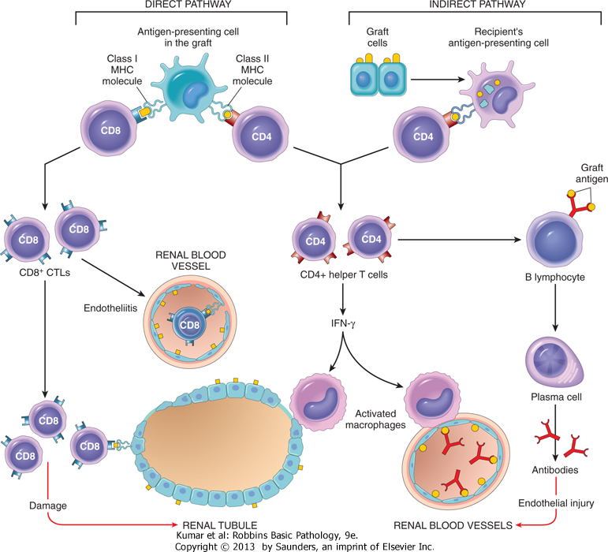
DIRECT: T CELLS RECOGNIZE FOREIGN AG
VIA APC

INDIRECT: AG SHED FROM GRAFT PROCESSED
BY APC AND PRESENTED TO HOST CD4
CELLS

Cell mediated rejection:
CD4 ACTIVATION: TH1—DTH
TH2- ANTIBODY
CD8 MEDIATED CYTOTOXICITY

Antibody mediated rejection:
PRE-FORMED ANTIBODY
B CELL ACTIVATION AND RESPONSE
TO FOREIGN ANTIGEN
TYPE II AND TYPE III RESPONSE

Morphology:
Depends on time frame
EXAMPLE: RENAL ALLOGRAFT

Hyperacute IMMEDIATE, PRE-FORMED ANTIBODIES (ABO) ? HOW FORMED
KIDNEY EXAMPLE: CYANOTIC, MOTTLED
NECROTIZING VASCULITIS, THROMBOSIS, ISCHEMIC NECROSIS OF GRAFT
CROSSMATCH: DONOR CELLS W/ RECIPIENT SERUM

Acute DAYS, WEEKS, MAYBE YEARS IF IMMUNOSUPPRESSION DECREASED
CELLULAR: LYMPHOCYTIC INFILTRATION (CD4, CD8)
TUBULITIS
ENDOTHELIALITIS
RESPONDS TO IMMUNOSUPPRESSION
CAN MIMIC CYCLOSPORINE TOXICITY
VASCULAR: ACUTE AND SUBACUTE VASCULAR INJURY
INTIMAL PROLIFERATION, LUMEN COMPROMISE, ISCHEMIA

Chronic
CORRELATES WITH PRIOR EPISODES OF ACUTE REJECTION, CUMULATIVE
EFFECT
VESSELS: INTIMAL FIBROSIS
GRAFT: INTERSTITIAL FIBROSIS AND ATROPHY

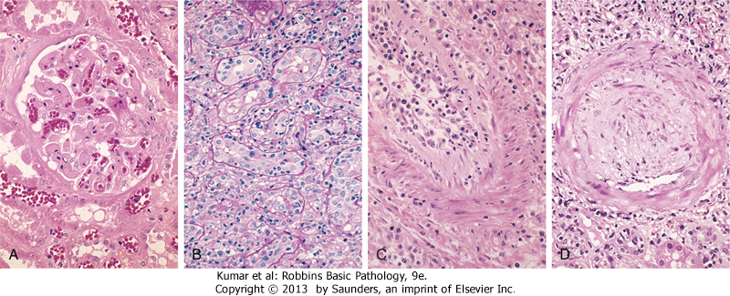

Methods of Improving Graft Survival

Compatibilitiy:

ABO: CROSSMATCH, ESSENTIAL

HLA antigens
HLA ANTIGEN TESTING OF DONOR WHEN POSSIBLE USING SEROLOGIC AND DNA/MOLECULAR BASED ASSAYS
IDENTIFYING ANTIBODIES IN RECIPIENT: FLOW CYTOMETRY “CROSSMATCH”
FOR BONE MARROW: EXACT MATCH IS IMPORTANT TO AVOID GVHD

Immunosuppressive Therapy:

1) CORTICOSTEROIDS

2) CYCLOSPORIN (FUNGAL PRODUCT)
BLOCKS IL2 PROD. BY INHIB
CALCINEURIN PATHWAY

3) AZATHIAPRINE, MYCOPHENOLATE MOFENETEIL
INTERFERE WITH DNA SYNTHESIS

4) TACROLIMUS (FK506)
SIMILAR TO CYCLOSPORINE

5) ANTI-CD3 (OKT3), ANTI IL2 RECEPTOR (DACLIZUMAB)

6) OTHER AS ILLUSTRATED

DATA:
1955- FIRST RENAL TXP 0% SUCCESS
1962- AZATHIAPRINE, PREDNISONE: 45-50% 1 YEAR SUCCESS
70S: LRD, NEW DRUGS
IMPROVED SUCCESS, LYMPHOCYTE-SPECIFIC, WEAK POTENCY AGAINST MEMORY CELLS, MINIMAL SIDE EFFECTS

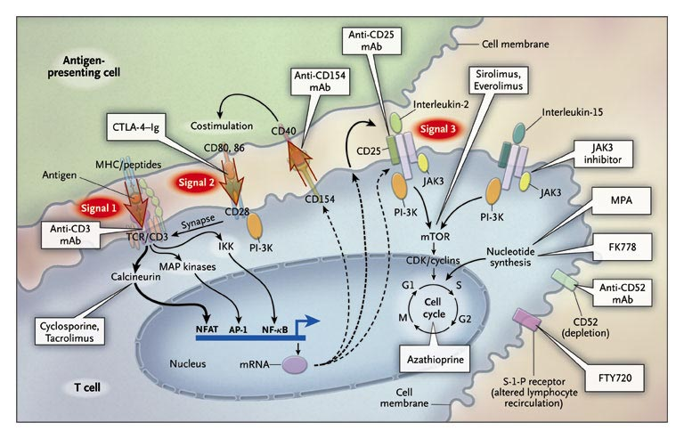

NEJM Vol 351; 26 Dec 2004

Other factors to consider:
ORGAN AVAILABILITY
SIZE CONSTRAINTS
RECURRENT DISEASE

Bone Marrow Transplantation (Hematopoietic Stem Cells)
SOURCE: PERIPHERAL BLOOD, UMBILICAL CORD BLOOD

PROBLEM:
Graft versus Host Disease

Pathogenesis
CD8, CD4 CELLS FROM GRAFT REACT AGAINST DONOR ANTIGENS
GREATER THE MISMATCH, GREATER THE CHANCE OF GVHD

Acute GVHD
DAYS-WEEKS
SKIN, LIVER, GI SYSTEM

Chronic GVHD
VARIABLE, YEARS
SCLERODERMA-TYPE SKIN CHANGE, CHRONIC MUCOSAL CHANGES GI TRACT
LYMPHOID ATROPHY

Treatment
IMMUNOSUPPRESSION
? ELIMINATE CELLS FROM GRAFT (INCREASED RELAPSE RATE OF LEUKEMIA)

NOTE: GVHD CAN ALSO OCCUR IN SOLID ORGANS WITH LOTS OF LYMPHS (LIVER) AND WITH NON-IRRADIATED BLOOD TRANSFUSION

Other Complications of Transplantation

Opportunistic infections
CMV, FUNGI, BACTERIA

Post Transplant Lymphoproliferative Disorders (PTLD)
EBV-DRIVEN
RELATED TO IMMUNOSUPPRESSION
RX: DECREASED IMMUNOSUPPRESSION RX, +/- CHEMO

Laboratory Assessment of Immune Status

Testing of Humoral Immunity:

1)

2)

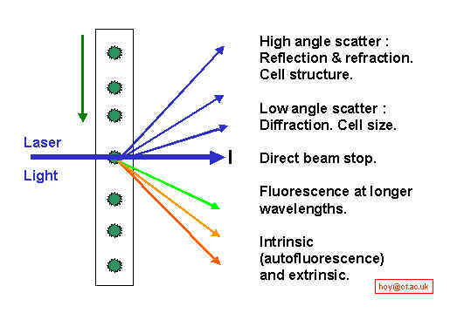
Testing of Lymphocyte Number and Function:

1)

2)

3)

In Vivo Testing of Immune Function

Testing of Innate Immunity

Neutrophils:
Number and Function

NBT test:

Complement:

Total

Components
Immunodeficiency: Congenital and Acquired

Acquired versus Congenital Immunodeficiencies

1)

2)

Congenital Immunodeficiencies

Clinical Manifestations of Congenital Immunodeficiencies

Infections
T cell defects:

B cell defects:

Granulocytes:

Complement:

Time frame:

Other manifestations:
1)
2)
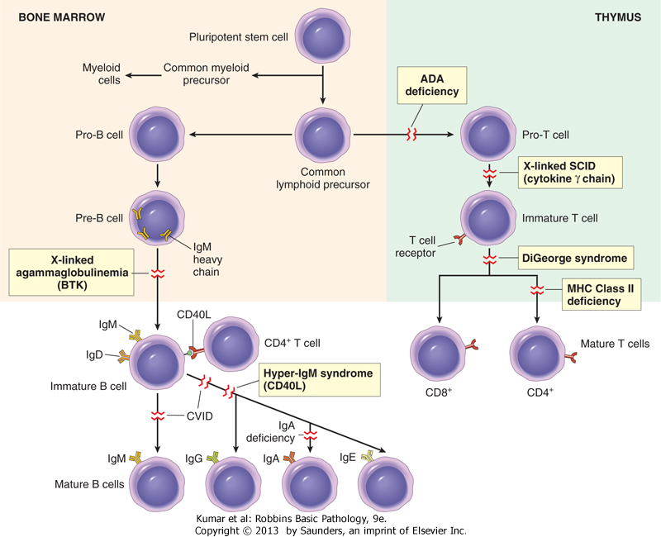

Selected Congenital Immunodeficiencies:

Disease with abnormal Immunoglobulin Production

X-linked (Bruton's) Agammaglobulinemia

Incidence:

Clinical features:
1)

2)

3)

Molecular defect:

Other manifestations:

Treatment:

Common Variable Immunodeficiency (CVID)

Incidence:

Clinical features:
1)

2)

Molecular defect:

Other manifestations:

Isolated IgA Deficiency

Incidence:

Clinical features:
1)

2)
Molecular defect

Other manifestations

Hyper-IgM Syndrome

Incidence:

Clinical features:
1)

2)

Molecular defect:

Other manifestations:

Diseases with predominantly T cell abnormalities

Severe Combined Immunodeficiency (SCID)

Incidence:

Clinical features:
1)

2)

3)

Inheritance

Molecular defects:

1)

2)

3)

Treatment (retroviral gene transfer, BM transplantation)
Other Congenital Syndromes:

DiGeorge Syndrome (22q11 deletion syndrome)
C
A
T
C
H
22

Wiskott-Aldrich Syndrome:
Triad:
1)

2)

3)

Inheritance
Molecular defect

Other manifestations:

Deficiencies of Innate Immunity

Complement deficiencies

1)

2)

3)

Neutrophil Deficiency

Chronic Granulomatous Disease (CGD)

Acquired Immunodeficiency: Pathology and Pathogenesis of HIV Infection

Epidemiology

Worldwide distribution of HIV Infection

Risk Groups:

Men who have Sex with Men (MSM)

Intravenous Drug Users

Heterosexual contacts of high risk groups

Blood and Blood-product recipients

Hemophiliacs

Children born to HIV infected women (vertical transmission)

Mode of Transmission
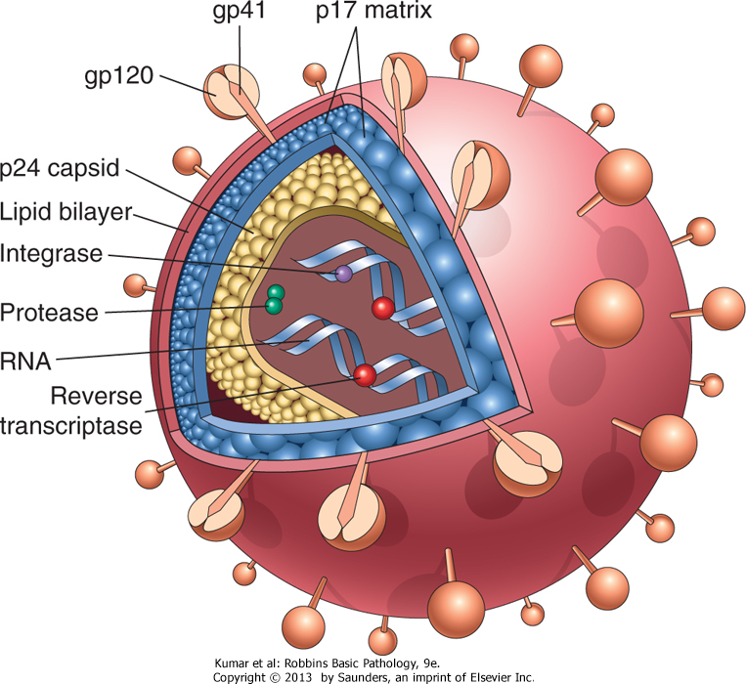
Sexual

Parenteral

Mother-to-Infant

Virology

HIV 1 and HIV 2

Viral structure

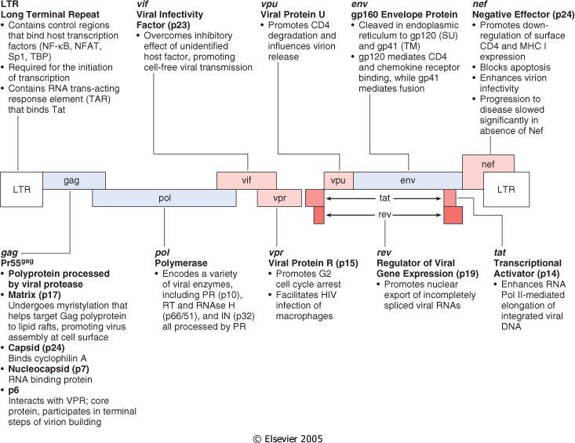
Viral Genome

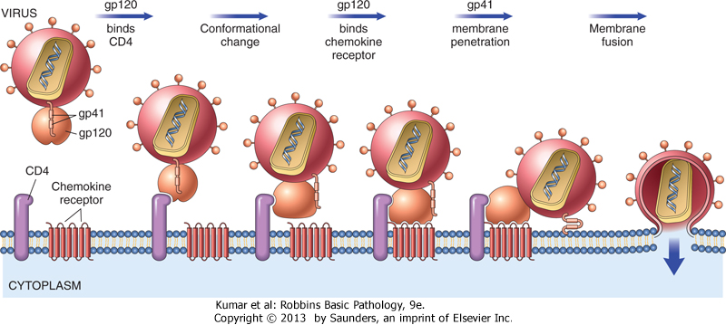

Viral Entry

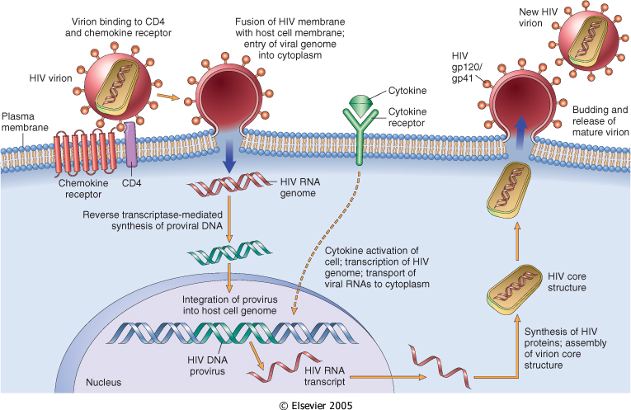

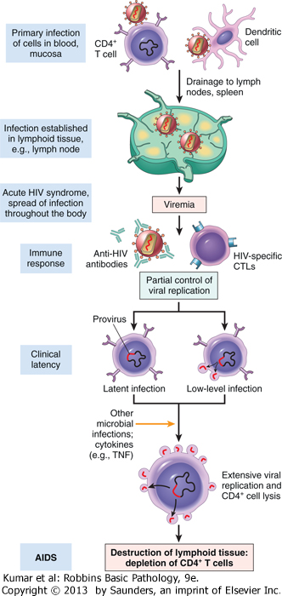
Pathogenesis of Infection

T Cell Destruction

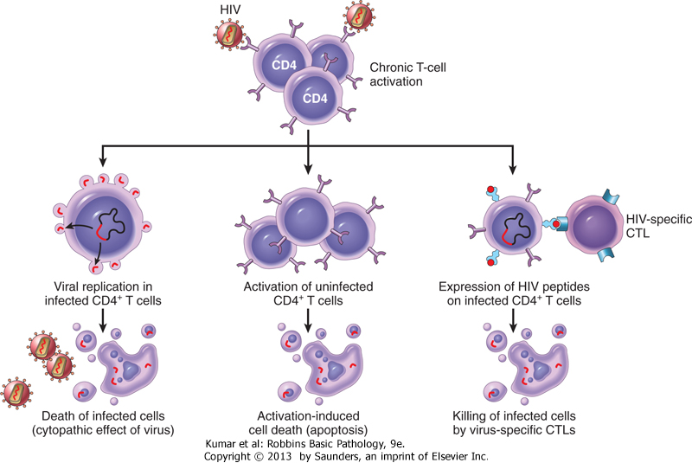
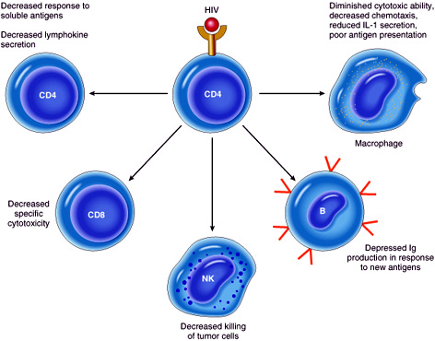
Immunologic Consequences of
T Cell Loss

Macrophages and Dendritic Cells and HIV

CNS Involvement by HIV

Clinical and Immunologic features of Natural History of HIV Infection

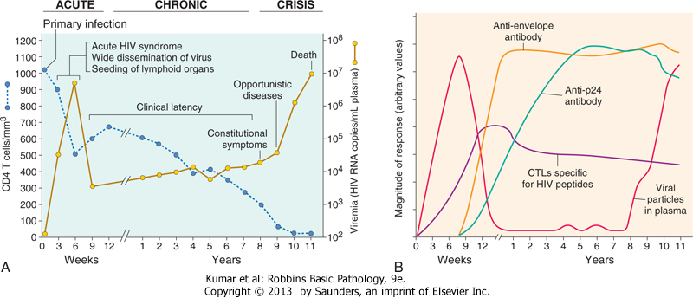

Clinicopathologic Features of AIDS

"Acute HIV" Illness

HIV associated Lymphadenopathy

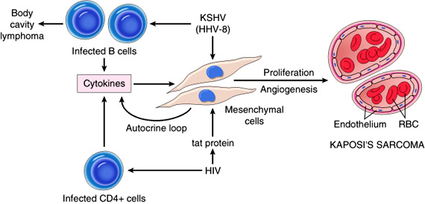
HIV and Lymphomas

Kaposi's Sarcoma

Cervical and Anal HPV-mediated Neoplasia

Central Nervous system
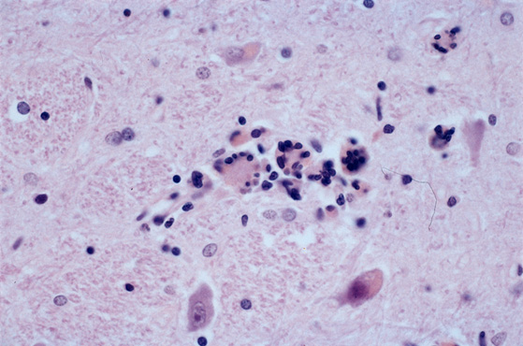
1)

2)

3)

4)

Infections

Bacterial/Mycobacterial

Community acquired bacterial infection

Mycobacterium tuberculosis and Atypical mycobacteria

Fungal and Protozoal

Candida albicans

Pneumocystis jeroveci

Histoplasma capsulatum

Cryptococcus neoformans

Cryptosporidium

Toxoplasma gondii

Viral

Cytomegalovirus

Herpes simplex

Epstein Barr Virus

JC Virus

Laboratory Testing in HIV Infection

Diagnosis:

Enzyme Linked Immunosorbant Assay (ELISA)

Western Blot (confirmatory)

P24 antigen testing

PCR for HIV RNA/DNA

Monitoring Disease Progression and Prognosis:

HIV mRNA by PCR

CD4 lymphocyte Quantitation

Tailoring Drug Therapy/Detecting Resistance:

HIV genotyping
Amyloidosis

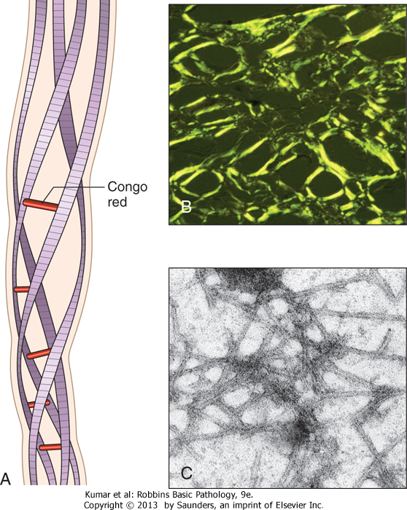
Definition:

Characteristics of Amyloid

Pathogenesis:

A disorder of abnormal protein
Folding.

AL amyloid

AA amyloid

Aβ amyloid

Transthyretin

β2 microglobulin

Endocrine sources

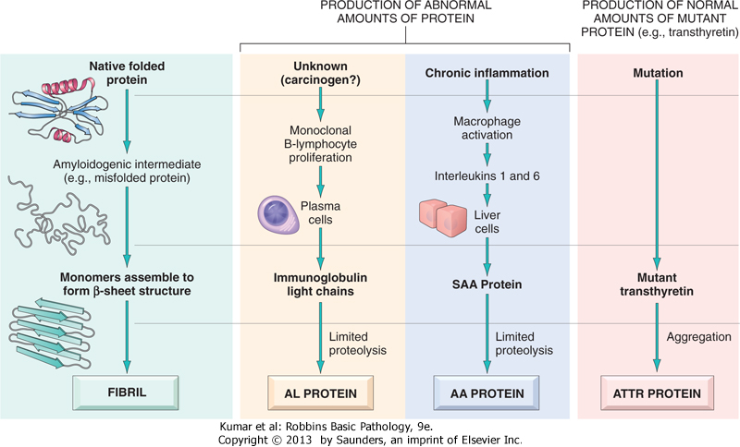

Pathology of Amyloidosis:

Clinical Presentation and Diagnosis

Treatment and Prognosis
Immunopathology Study Questions

Transplantation:
- What is the difference between direct and indirect allograft recognition?
- In acute rejection of the kidney, what pathologic change typifies cellular rejection? Antibody-mediated rejection?
- What antigen system(s) are most important in graft rejection
- How does HLA mismatch affect the probability of Graft vs Host disease (GVHD)?
- What major organ systems are affected by GVHD?
- Post transplant lymphoproliferative disorder is associated with what viral pathogen?

Autoimmunity
- What are the major clinical signs and symptoms of systemic lupus (SLE)?
- What is a wire loop lesion?
- What is the significance of a positive ANA in an asymptomatic individual?
- What specific autoantibodies are helpful in the diagnosis of SLE?
- How do discoid and drug-associated lupus differ from SLE?
- Based on current knowledge, what main mechanisms are involved in immunologic tolerance?
- Lupus is latin for ___________?
- What is the antiphospholipid antibody syndrome? What is the relationship of APS to lupus?
- Give an example of each of 3 different types of hypersensitivity reactions occurring in SLE.
- Fibrous tissue deposition occurs most commonly in which organs in progressive systemic sclerosis (scleroderma, PSS)?
- What is the pathogenesis of PSS?
- What specific autoantibody(ies) is/are helpful in diagnosis of PSS? CREST?
- What does CREST stand for?
- True or False. Some patients can have spontaneous softening of their dermal sclerosis after years of disease.
- What severe complication can be seen in PSS associated renal disease?
- What is Raynaud’s phenomenon?
- What is sicca syndrome?
- Sjogren’s syndrome is most commonly associated with what other autoimmune disease?
- What specific autoantibody(ies) is/are helpful in the diagnosis of Sjogren syndrome?
- Anti-Jo and Anti-La are associated with what autoimmune disease (es)
- How do dermatomyositis and polymyositis differ in terms of the target of the inflammatory process?
- Patients with mixed connective tissue disease commonly have what autoantibody?
- What is the genetic basis for Bruton’s agammaglobulinemia?
- What infections are commonly associated with B cell deficiencies? T cell deficiencies?
- Adenosine deaminase deficiency and Jak 3 mutations are associated with what congenital immunodeficiency?
- What immunodeficiency is associated with anaphylactic reaction to transfusion of plasma-containing products?
- The triad of eczema, thrombocytopenia, and recurrent infections is seen in what congenital immunodeficiency?
- Which inherited immunodeficiency syndrome is associated with hypocalcemia?
- What risk group has shown the greatest increase in proportion of new HIV infection over the last decade in the US?
- What are major determinants of sexual transmission of HIV?
- What are major determinants of perinatal transmission of HIV?
- What is the significance of the LTR (long terminal repeat) region of the HIV genome?
- How do CD 4 cells and macrophages bind HIV? How do they differ in terms of their interaction with the virus?
- How is B cell function affected by HIV disease?
- HIV is an a. RNA b. DNA virus?
- How do CD4 count and Viral RNA quantitation (viral load) differ in terms of their clinical significance?
- What are the “co-receptors” involved in HIV binding and entry?
- Where does HIV virus reside during the clinical “latent” period?
- How does HIV gain access to the central nervous system?
- List several important mechanisms for T cell destruction in the course of HIV infection
- How do the ELISA and Western Blot assays differ in terms of their role in diagnosis of HIV infection? What are causes of false positive ELISAs?
- What is the pathogenesis of kaposi’s sarcoma?
- What happens to the lymphoid tissues during the course of HIV/AIDS?
- What malignancies are seen in higher frequencies in patients with HIV infection?
- What is PML?
- What are the most common clinical manifestations of the following opportunistic pathogens in the setting of HIV infection?
  - Cryptococcus neoformans
  - Pneumocystis carinii
  - M. tuberculosis and M. avium complex
  - Histoplasma capsulatum
  - Toxoplasmosis
  - JC virus

- What type of amyloid protein is associated with each of the following?
  - Plasma cell dyscrasia
  - Systemic infection/inflammatory disorder
  - Alzheimer’s disease
  - Medullary thyroid carcinoma
- What special stain is used to identify amyloid on tissue biopsies?
- What tissues are most commonly affected in systemic amyloidosis?

